**Day 4 - Building Dynamic Frontend**

**Components for Comforty**

# Introduction

This report highlights the development of dynamic and responsive frontend components for **Comforty**, an ecommerce platform focused on selling furniture, specifically chairs. The main focus areas include:

1. **Dynamic Product Display**: Fetch chair products dynamically from the backend to ensure up-to-date listings.
2. **Search and Filters**: Implement a search bar and filters for users to find chairs based on style, material, and price.
3. **Product Listing Page**: Create a dynamic page displaying all chair products with name, price, and brief descriptions.
4. **Product Detail Page**: Develop a page with detailed product info, images, pricing, available sizes, and an option to add to the cart.
5. **Functional Cart**: Build a cart system for users to add chairs, modify quantities, and proceed to checkout efficiently.

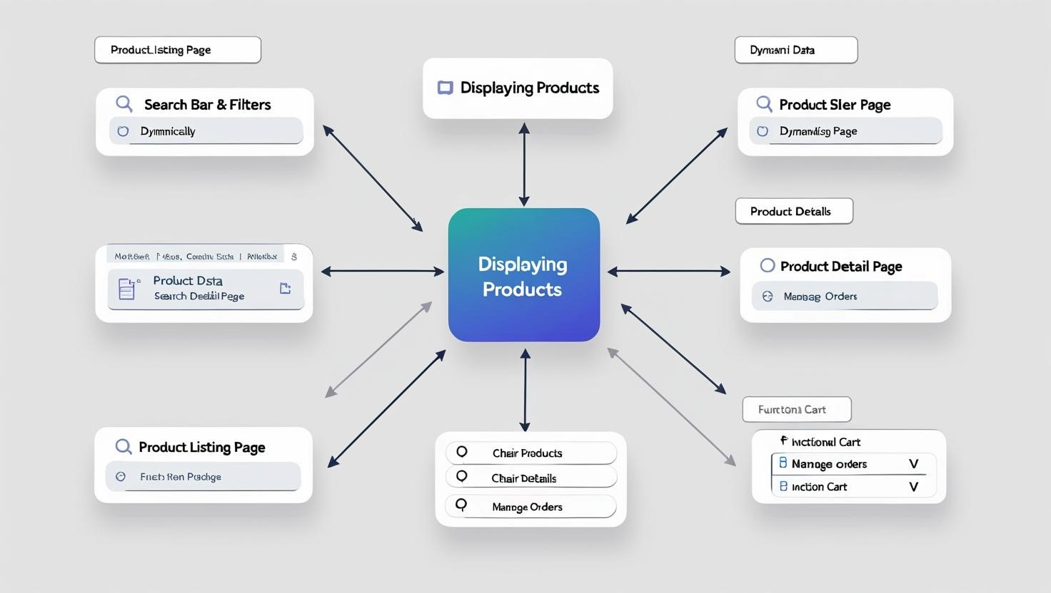

# Product Listing

* **Dynamic Product Display**: Fetched chair product data from the Sanity Api.
* **Responsive Grid Layout**: Displayed chair products with names and prices in a grid that adjusts to screen size.

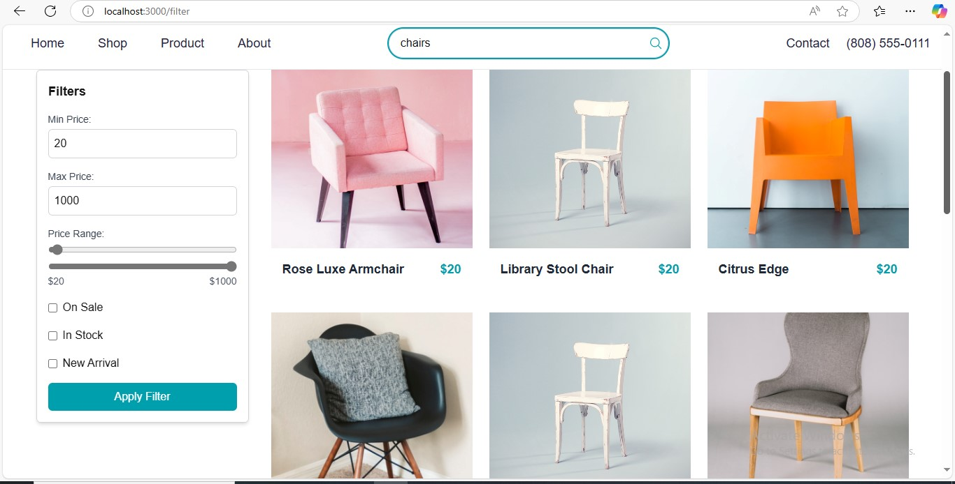

# Product Detail Component:

* **Dynamic Routing**: Created individual chair product detail pages using dynamic routing in Next.js.
* **Detailed Information**: Included key details such as product description and price, and add to cart button.

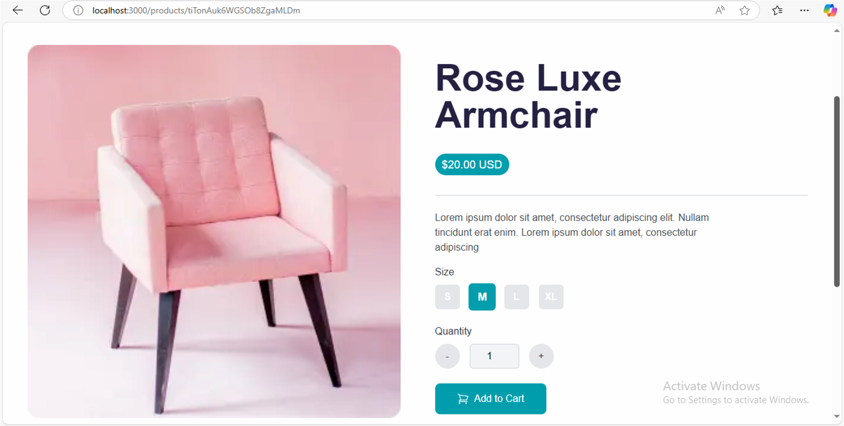

# Category Component:

* .**Dynamic Category Display**: Displayed chair categories dynamically fetched from the data source.
* **Product Filtering**: Enabled filtering of chair products based on selected categories

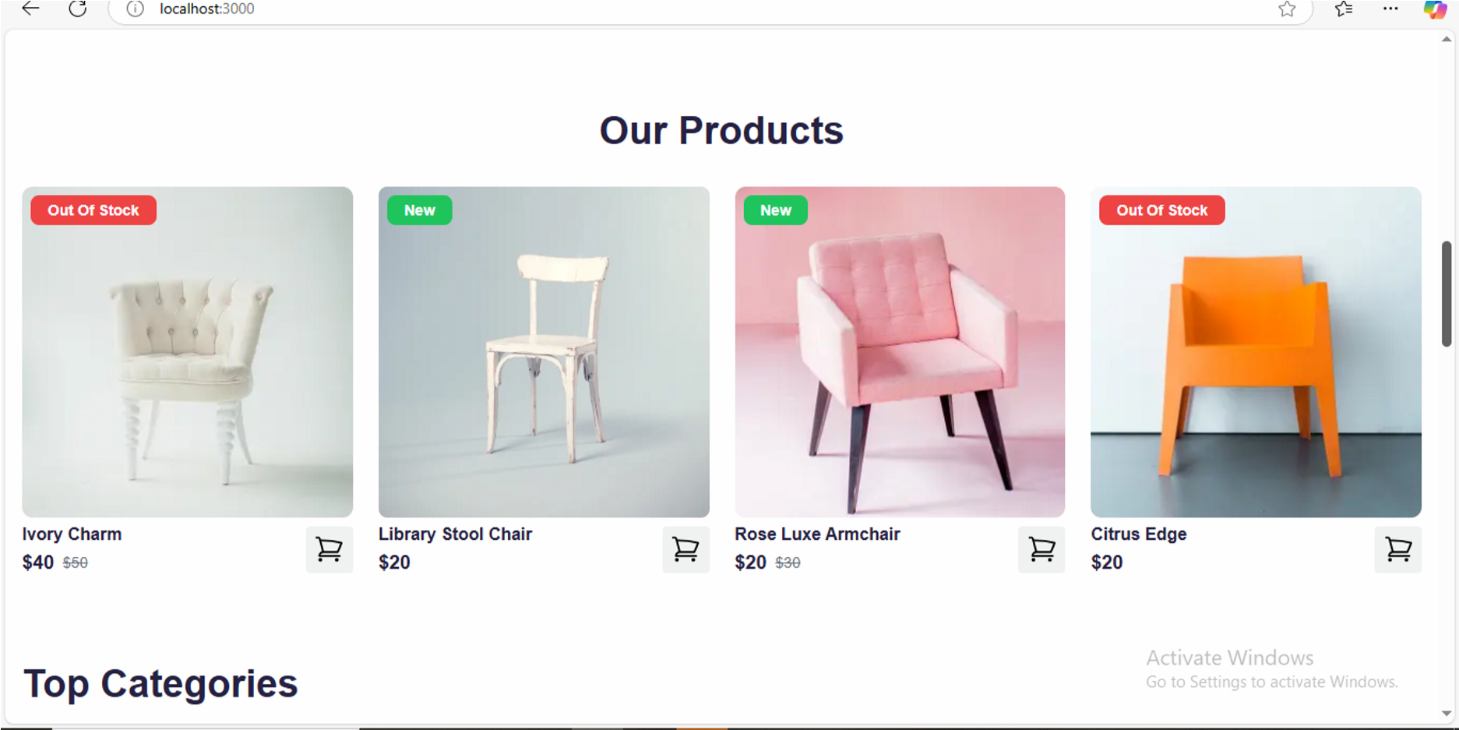

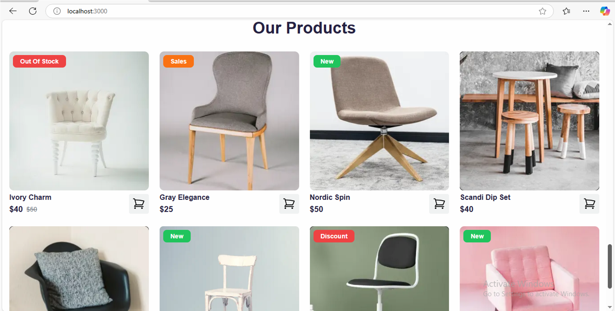

# Search Bar and Filters

* **Real-Time Search**: Created a search bar for real-time product filtering by name or tags.
* **Category Filters**: Integrated filters based on chair categories, fetched dynamically from the API.

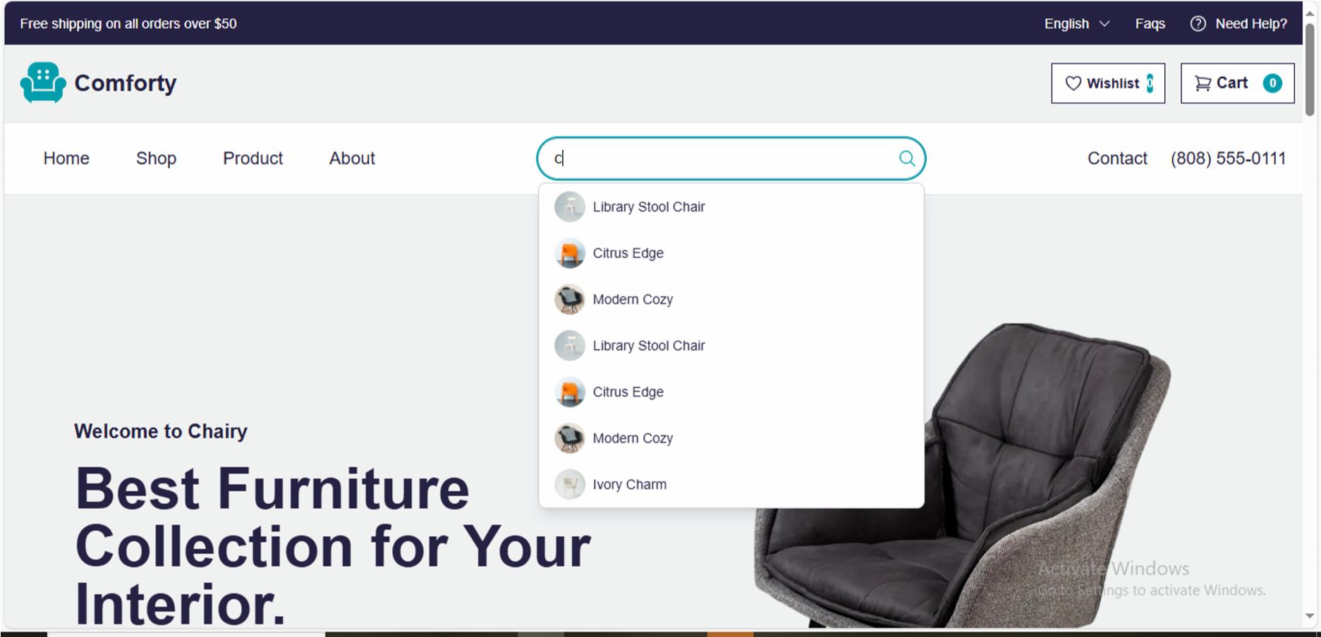

# Cart Component

* **Functional Cart**: Developed a cart system for adding, viewing, and modifying chair quantities.
* **Delete and Favorite Options**: Integrated functionalities for deleting items and marking chairs as favorites.
* **Checkout Integration**: Enabled users to proceed to checkout and manage their orders efficiently.

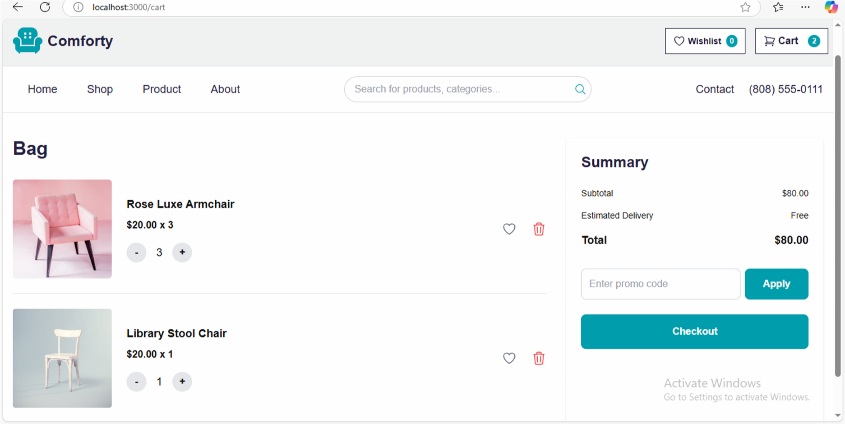

# Wishlist Component

* **Wishlist Functionality**: Developed a wishlist feature for users to save their favorite chairs for future purchase.
* **Easy Access**: Enabled users to view and manage their saved chairs with the option to add them to the cart later.

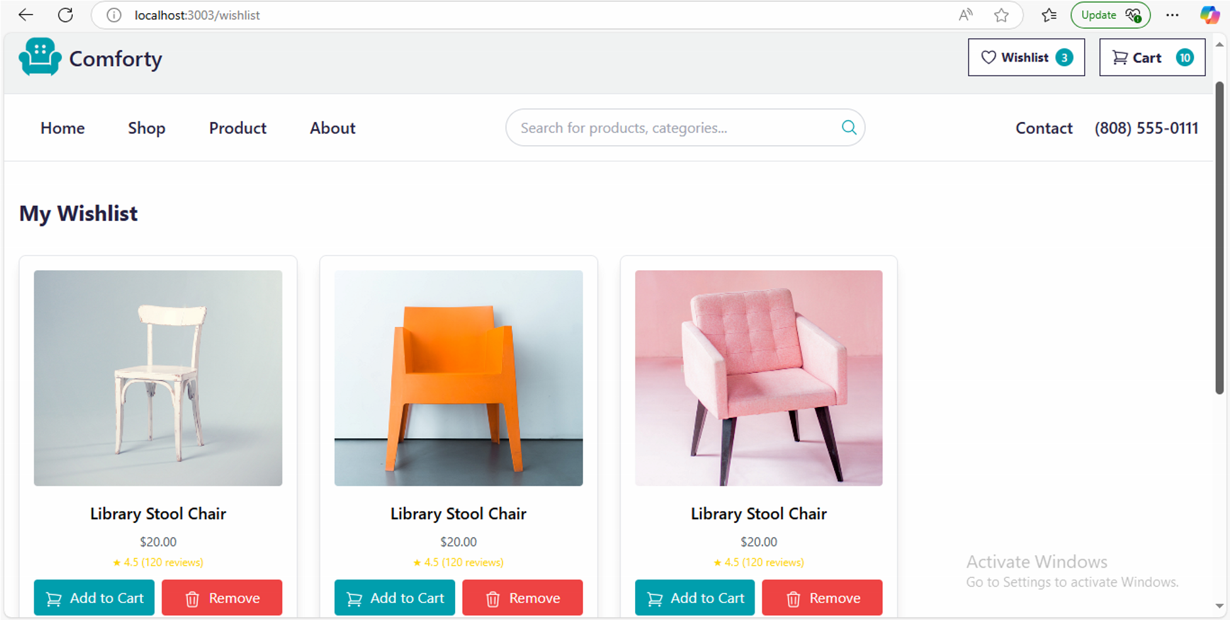

# Step 7: Checkout Flow Component

* **Checkout Process**: Developed a streamlined checkout flow where users can review their cart, input shipping and billing addresses, and select payment methods.
* **Order Confirmation**: Included an order confirmation page summarizing the purchase with estimated delivery details.

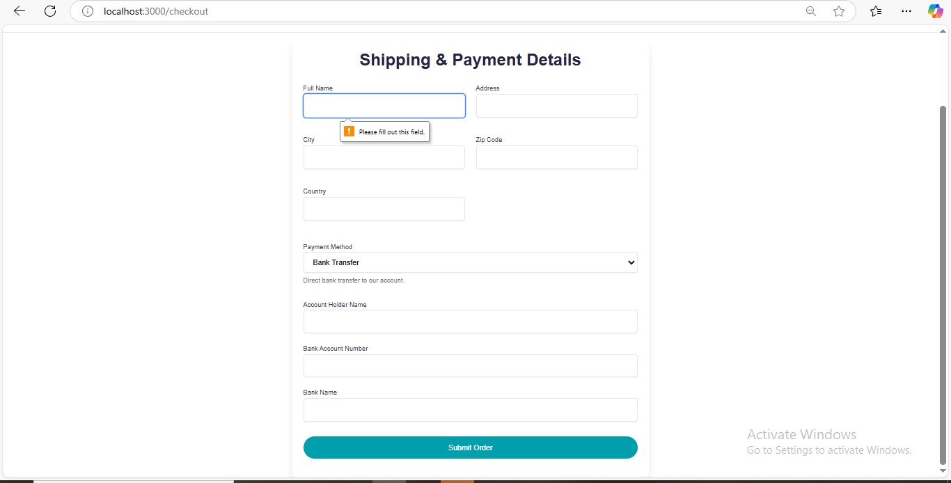

# Self-Validation Checklist:

**F**

**r**

**o**

**n**

**t**

**e**

**n**

**d**

**C**

**o**

**m**

**p**

**o**

**n**

**e**

**n**

**t**

**D**

**e**

**v**

**e**

**l**

**o**

**p**

**m**

**e**

**n**

**t**

**:**

**S**

**t**

**y**

**l**

**i**

**n**

**g**

**a**

**n**

**d**

**R**

**e**

**s**

**p**

**o**

**n**

**s**

**i**

**v**

**e**

**n**

**e**

**s**

**s**

**C**

**o**

**d**

**e**

**Q**

**u**

**a**

**l**

**i**

**t**

**y**

**D**

**o**

**c**

**u**

**m**

**e**

**n**

**t**

**a**

**t**

**i**

**o**

**n**

**a**

**n**

**d**

**S**

**u**

**b**

**m**

**i**

**s**

**s**

**i**

**o**

**n**

✔

✔

✔

✔

***Author: Murtaza Hasnain***